PROFILE
Name | : | Ms.N.ANUSHA | 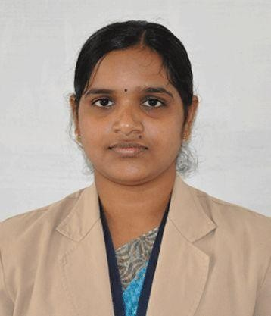
Designation |  | Assistant Professor
Department |  | Mathematics
Educational  Qualification |  | M.Sc., M.Phil., (Ph.D)
Subject of Interest | : | Fuzzy Mathematics
Publications : | : | International:  1. N.Anusha, A.Vincent Jeyakumar, J.Jayanthi,., presented, “ Sylvester Matrix Equations and their applications in fault tolerance in multiprocessors” in “Two day International Conference on Algebra and its applications organized by Department of Mathematics, PMU, Vallam held on December 14th& 15th 2011.  2.N.Anusha and A.George.,presented, Village Students Academic Performance – A Fuzzy Approach, International Journal of Innovative Research in computer and communication Engineering,Vol.4 special issue 5,ISSN(online): 2320-9801, ISSN (print) : 2320-9798,October2016  3.N.Anusha and A.George.,presented, Literacy rate in some PURA villages – aFuzzy Approach, Indian Journal of Scientific Research,ISSN:0976- 2876(print)ISSN: 2250 – 0138(online)pp 340-343, May 2017
National:
1.N. Anusha and A.George, presented, Fuzzy set – A modified approach, in “Two day National conference on Emerging Management and Technology practices” on October 2019.
2. N. Anusha and A.George, presented, Fuzzy analysis of factors affecting student performance, in “Two day National conference on Emerging Management and Technology practices”on October
2019.
Google Scholar Link | : | https://scholar.google.co.in/citations?hl=en&view_op=list_works

